**OPEN SOURCE CODING PART 1**

BAREFILE LEPHONDO ST10311574

NKOSINATHI MABENA ST10344257

LESEGO LETSAPA ST10351970

OPSC6311

Planning and Design  
  
Introduction

To achieve financial stability, one has to manage their personal finances effectively. This is something most people feel challenged with, tracking their expenses and just sticking to a budget. This is why we want to create “Middle Man”; Middle Man is a budgeting app designed to reduce the users financial management by acting as the middleman. This happens between the users and their spending habits thus slowly reducing overspending.

The aim is to take the research findings as a blueprint for the app. The Planning and Design phase includes the apps core features, designing a user interface and a project plan. When all this is done carefully not only will the Middle Man be functional but also engaging.

App Overview

App Name: Middle Man

A personal budgeting app made to help users to keep track of their expenses, they can also set goals, and analyze their spending habits all this would help users prevent overspending. The app’s purpose? It acts as the “middleman” between users and their financial decisions. This creates an environment where money can be managed way better and users learn financial discipline. The innovative features that Middle Man will include is:

Envelope Budgeting System – This was inspired by Goodbudget

Allocates money into different categories

Zero-Based Budgeting – This was inspired by YNAB

Every piece of money is assigned to avoid overspending

Goal-Based Budgeting – This was inspired by YNAB

Save towards a goal

Expense Tracking with Receipt Uploads

Photos of receipts can be attached by users

Shared Budgeting – This was inspired by Goodbudget and Wallet

Allows users to manage finances together

With these features users will be able to take full control of their finances.

Icon design 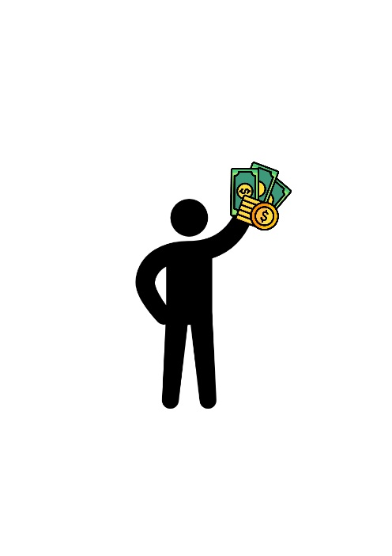

A detailed list of requirements for Middle Man

User Authentication and Security

* Users must be able to register, or create an account using a username, password and email
* Users should be logged out of the app once inactivity is detected this needs to happen automatically
* Users should be able to log in using their details (username and password)
* Forgot password feature should be included incase any users forget their password; they can select reset password then they do it through their emails that are registered

Expense Categories (Envelopes)

* Real-time updates will be shown to users on their spending vs budget
* Users will be able to create and manage envelopes
* A monthly budget limit can be set by users for each category
* Notifications will go out to users when they reach or exceed their budget for certain categories
* Users will be able to add, delete and edit the envelopes

Expense Entry and Tracking

* Users will be able to add on expense entry (just like in Goodbudget) but they need to specify (the amount spent, transaction date, expense description OPTIONAL, selected envelope, attach a photo of a receipt

The app will be able to store and display all expenses and users will be allowed to edit or delete entries of their choice.

Local Database and Data Storage

* Expenses, budget limits, receipts all need to be stored in a local database
* Database should support CRUD operations
* Export expense data as a CSV file

Notifications and Alerts

* Daily remainders to not forget to log expenses and fix your transactions if their wrong
* A budget sound alert when an envelope limit is close to be being exceeded

Dark mode/Light mode

* For user preference

User interface design

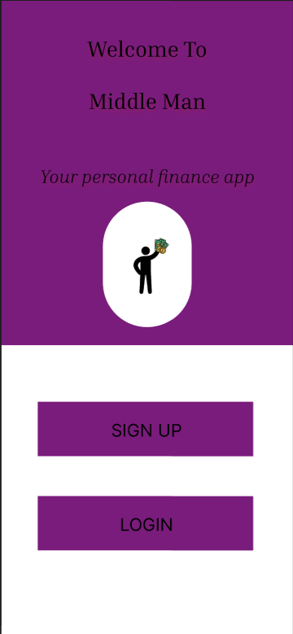 This is the Home screen of the application.

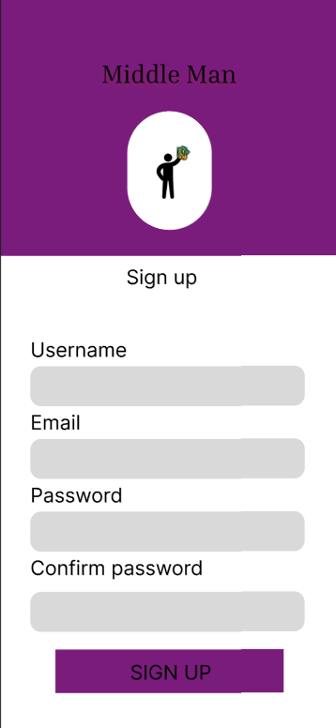After the user selects the sign up button on the home screen they will be taken to this screen in order for them to sign up on the app.

If the user selects Login from the Home screen they will be taken to this page in order for them to login onto the app.

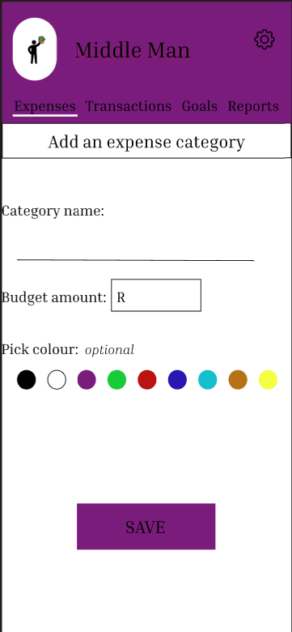After the user has successfully logged in they will be shown this page in order for them to create their own expense categories. They will be able to input the category name, the maximum amount they can spend on the category and an option to choose a color for that specific category in order to differentiate it from other categories. Afterwards the user saves and they will be taken to the next page.

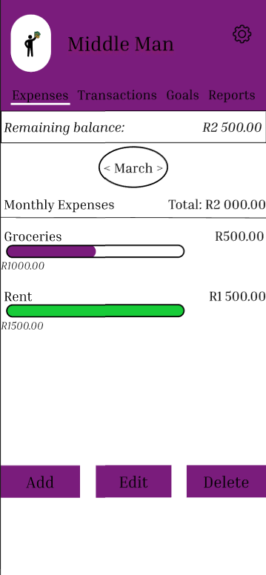On this screen the user will be shown all their expense categories they have entered along with the amount they have spent already and their remaining balance of their money.

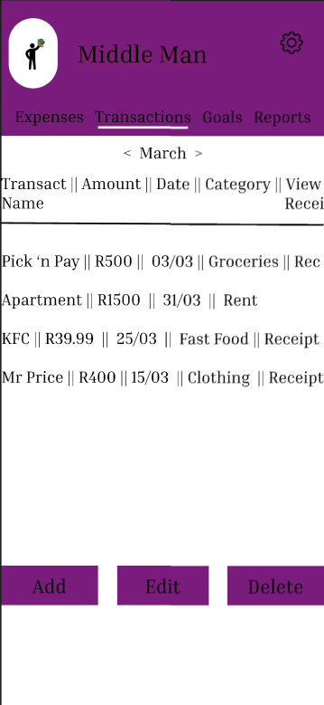If the user switches to the “Transactions” tab they will be shown all the transactions they have made during the selected month in this case which is March. On this page the user can see the name of the transaction, the cost of the item, the date on which it was transacted, the category which it belongs to and if they want to view the receipt of the product. At the bottom the user can add a transaction, edit a transaction or delete a transaction.

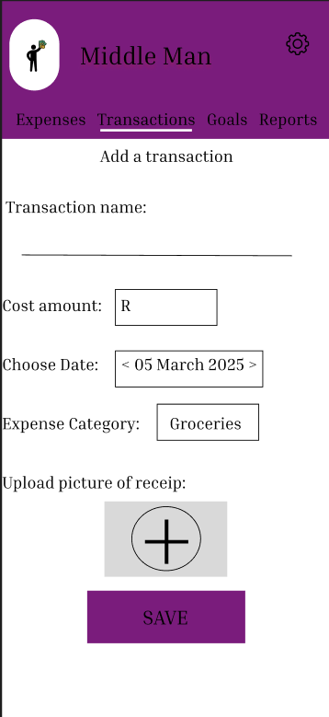 If the user wishes to add a transaction they will need to enter the name of the transaction, the amount spent, the date of the transaction, the category of which the transaction belongs in and an optional feature if they want to add a picture of the receipt.

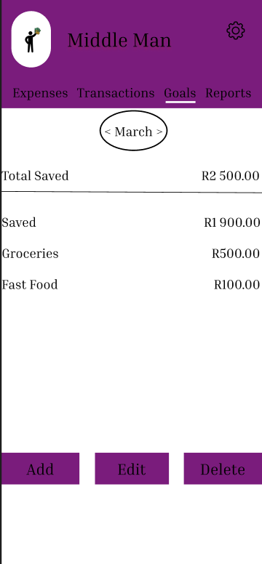 If the user switches to the “Goals” tab they will be able to view all the goals they are saving for and also how much they have already saved in each particular expense category. The user can add, edit or delete a goal.

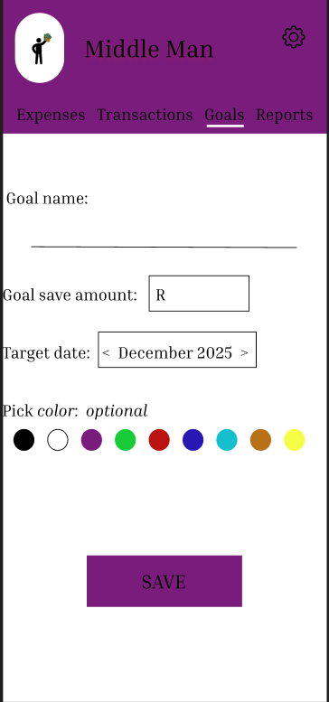If the user selects on add a goal and wishes to save towards a particular goal then they will enter the name of the goal, the amount that the user wishes to save, the date the user wishes to have saved the amount and an optional color change to the goal.

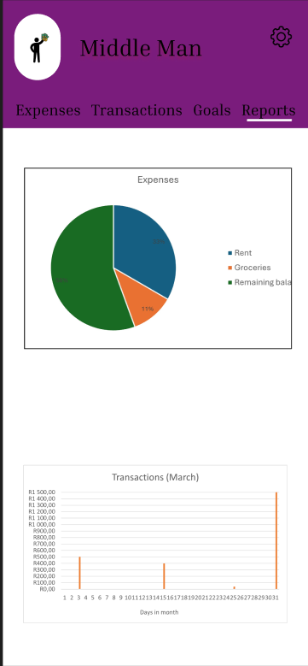If the user switches to the “Report” tab they will be able to see a graphical presentation of the expenses they spent in a pie chart and can view on which days of the month did they spend the most money. This graphical presentation of the users expenses is essential for the user in order to view if they have an unhealthy track record of spending money.

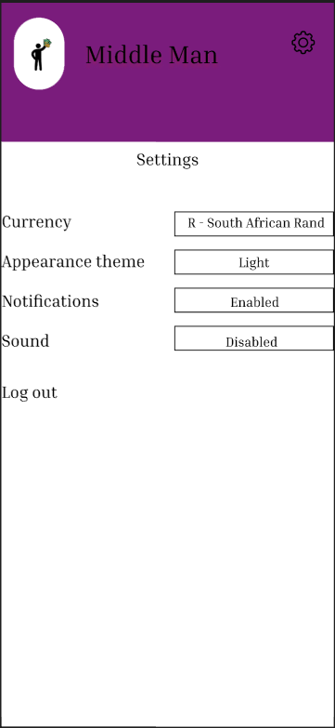The icon on the top right corner of the screen are the settings of the application. When selected the user can have some options to choose or change on the app like their preferred currency, the appearance of the app, if they want to enable or disable notifications, if they want sound on the app and an option to logout of the application.

This is just visual presentation of the app when the user changes the appearance theme of the app from light to dark mode.

DIAGRAM

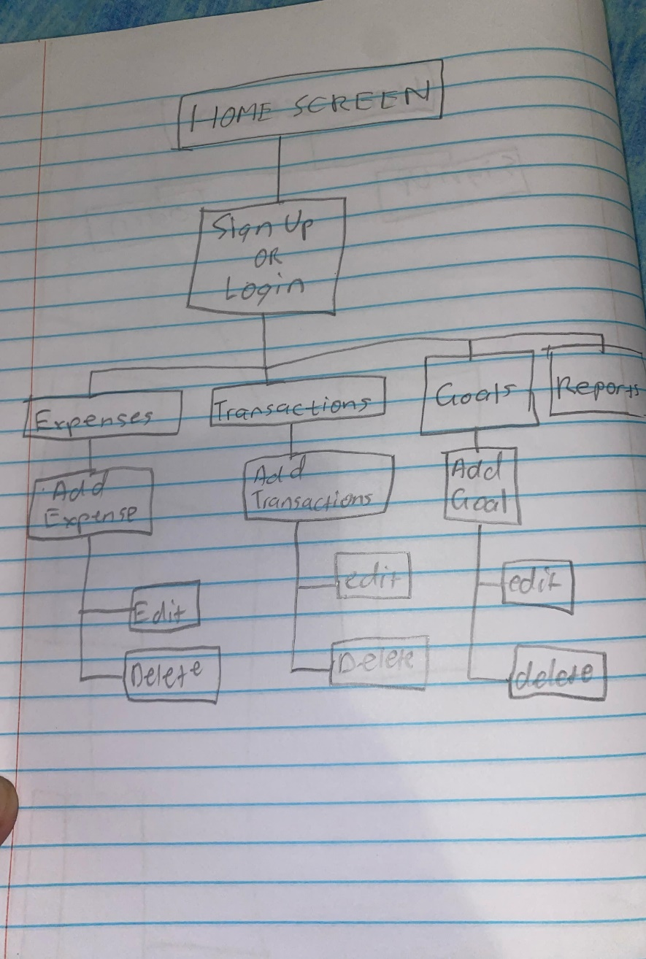

1. Middle man – personal budgeting app

1.1 Introduction

Managing our personal finances very well can be challenging for a lot of individuals, the common issues being overspending and poor budgeting. Middle man will be a budget app designed that will serve as an intermediary between the users and their financial habits, by implementing the envelope budgeting strategy, zero-based budgeting strategy and the goal-based budgeting strategy. Middle man will also help users take control of their spending, track expenses and work towards financial stability.

1. Purpose of the Project Charter

The purpose of this project charter is to have a clear plan for the Middle man budgeting application, so that all parties involved in the project is on the same page as far as the project goal, scope, and deliverables are concerned. This is the formal agreement document that defines the project boundaries, deliverables, risks and timelines. It will guide the development process and serve as a map to keep the project on track and moving towards its intended goals. The charter will also help in securing approval from key stakeholders and in allocating resources correctly.

1. Product overview

3.1 Product Description

Middle man is a mobile application for empowering users to be in full control of their money by tracking incomes, setting budget limits, and monitoring expenses in real-time. It acts as an intermediary between consumers and money choices providing them with insights and structured budgeting tools for cutting down wastage and improving financial control.

3.2. Key features

Budgeting systems:

* Envelope budgeting: allocate money into different categories
* Zero-based budgeting: assign money to a specific category to avoid unnecessary spending.
* Goal-based budgeting: set and track savings goal

Expense tracking:

* Add, edit, delete expense entries.
* View real-time spending and budget updates

Shared Budgeting:

* Collaborate with loved ones on shared financial goals

Customization and usability:

* Light mode/dark mode for user preference
* Intuitive navigation and visually appealing UI/UX

Security and user authentication:

* Secure Authentication with encryption
* User registration/login
* Forgot password feature

Our target are individuals looking to gain better control over their spending.

1. Project deliverables

* Mobile Application: Fully functional android app
* Testing reports: Performance and security testing results
* App prototypes and wireframes: UI/UX design of Middle man
* Project documentation: requirement specifications, development plan and database schema

1. Stakeholders

* Development team: UI/UX designers, mobile app developers, backend developers
* QA team: testers ensuring app functionality and security
* End users: Individuals seeking better financial management

1. Project Timeline

|  |  |  |  |
| --- | --- | --- | --- |
| Phase | Start date | End date | deliverables |
| Research and planning | 18 March 2025 | 2 April 2025 | Research report, requirement document |
| UI/UX design | 28 March | 2 April 2025 | Wireframes, prototypes |
| Development | 8 April 2025 | 12 May 2025 | Draft version of app |
| Testing and QA | 12 May 2025 | 18 May 2025 | Bug fixes, test |
| Deployment and marketing | 25 May 2025 | 6 June 2025 | App store listing |
| Post-launch maintenance | Ongoing | ongoing | updates |

1. GANT CHART

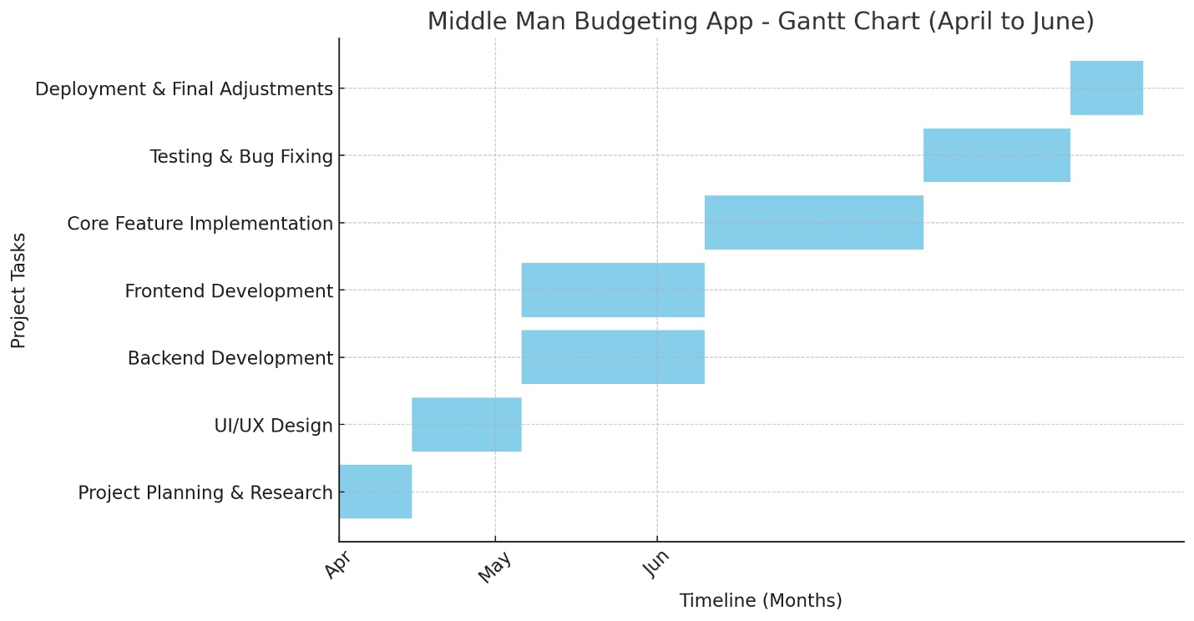

1. Assumptions and Constraints

Assumptions:

* Users will need to have mobile devices that have internet access
* App will be used by individuals with different types of financial literacy goals
* Security measures will be included to protect user data

Constraints:

* Budget limitations for development and marketing
* Mobile OS compatibility

1. Risk Management

|  |  |  |  |
| --- | --- | --- | --- |
| Risk | Likelihood | Impact | Mitigation strategy |
| Technical issues | Medium | High | During testing |
| Budget overrun | High | High | Regular budget reviews and prioritization of features |
| User adoption challenges | Medium | Medium | Tutorials, and marketing |
| Data security | Medium | High | Implement strong encryption and authentication |

In conclusion we would say that the Planning and Design phase has created what we can call a solid foundation. We found important features and cutting-edge components that will improve the user experience by analyzing the three existing budgeting apps. We have made sure that Middle Man would be easy to use, effective, and flexible enough to accommodate different financial needs by clearly defining requirements, creating user-friendly interfaces, and putting in place a sensible navigation structure. The project charter maintains the development process in line with our objectives by giving it a defined direction.

REFERENCING LIST

<https://www.nerdwallet.com/article/finance/best-budget-apps>

<https://morganfranklinfoundation.org/financial-tools-the-pros-cons-of-goodbudget/>

<https://www.usertesting.com/blog/innovative-features-for-product-pages>